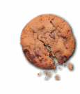
“As the Cookie Crumbles”
Advertising Campaign

Michael Bivens
ReigningPages for Expert Auto Collision

OBJECTIVE: To increase awareness of the business in the local area and increase customer satisfaction and favorable reviews thereby increasing the customer flow.

IMPLEMENTATION: Each customer is presented with a small decorative cookie gift upon payment and pick-up of their vehicle.

EXAMPLE of CONCEPT:
A car-shaped gingerbread cookie with several attached cookies (on-a-stick) with decorative tissue paper and promotional materials (biz card, thank you card, etc.)
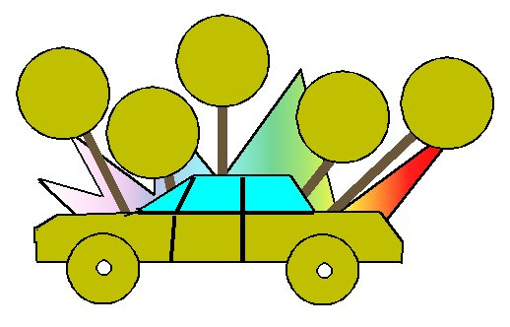

Other Examples:
A similar product to the concept product is available at http://www.cookiesbydesign.com/

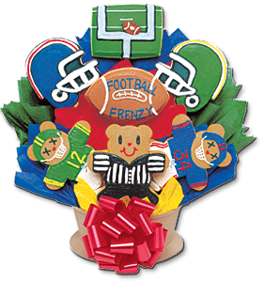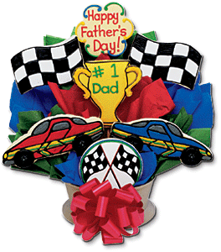
TEST of Concept:
Cookie cutters and various shape ideas
 | 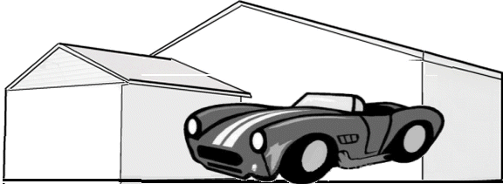
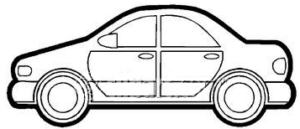 | 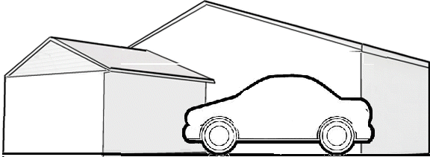
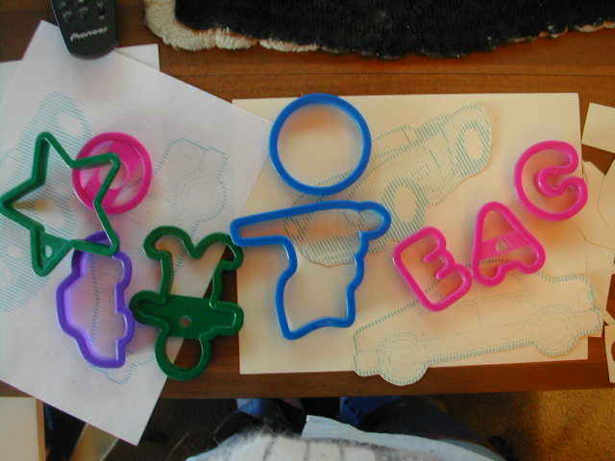 | 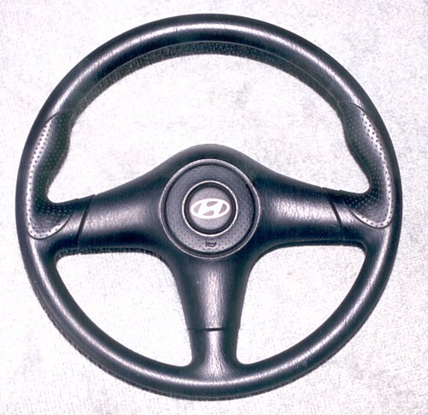

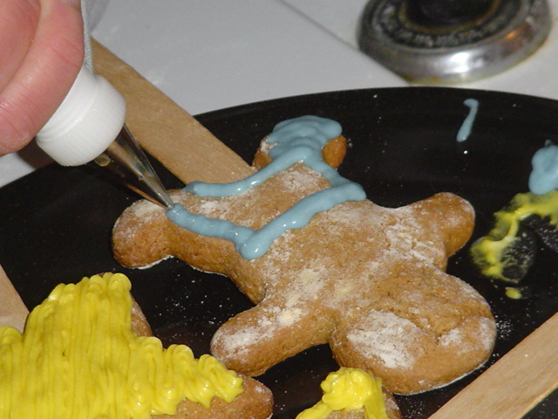 | Cookies baked (on sticks),  decorating begins
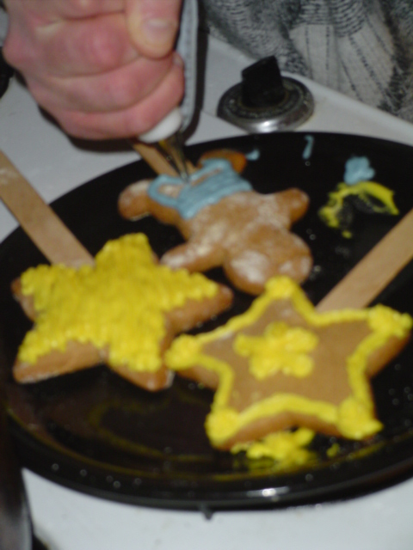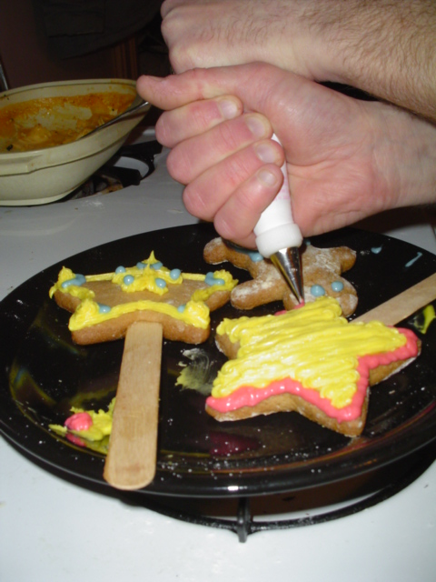

Samples of finished Cookies | 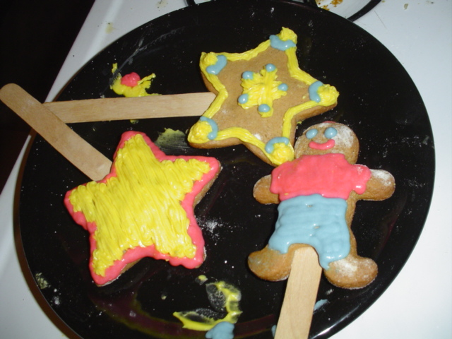

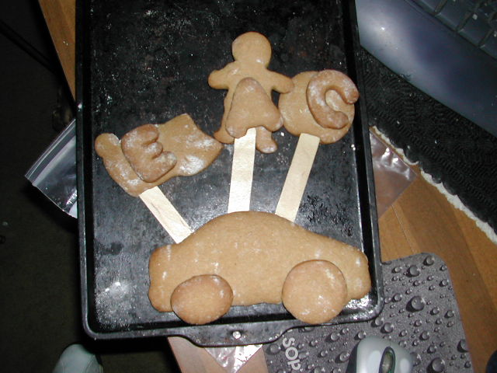 | 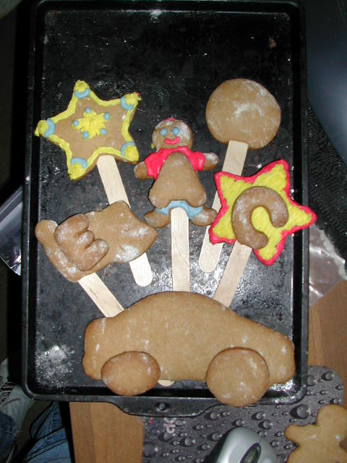
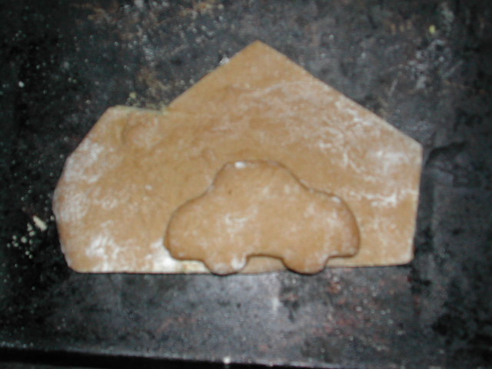 | 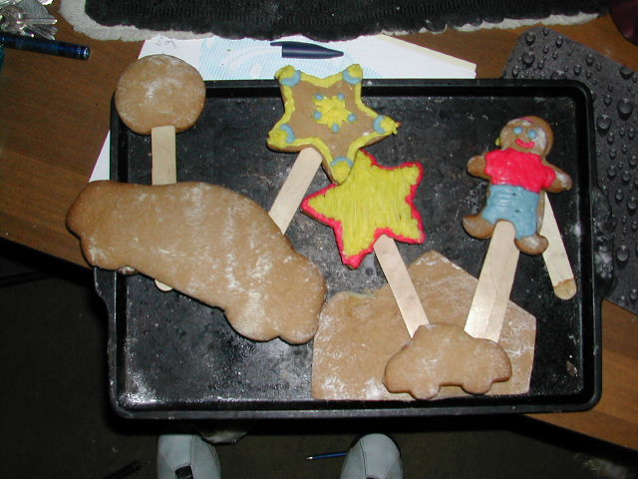

My doggies watched the whole procedure with great interest. Of course, I love them and spoil them already, so they did taste the product … and watched for any crumbs to fall. | 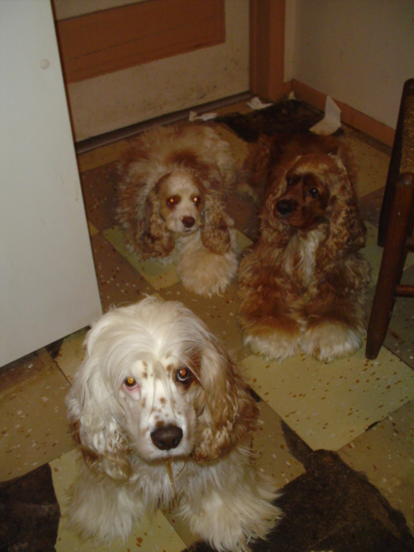
Zeus   Aries

  Showing off the Product | 

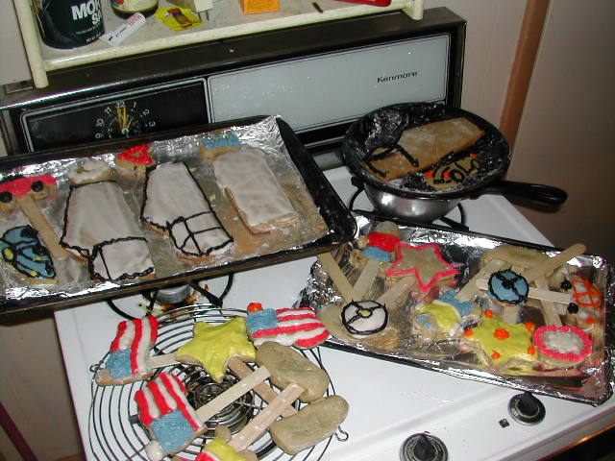 | Constructing the Sample Products
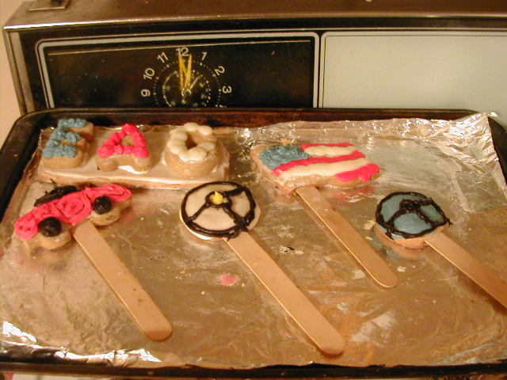 | 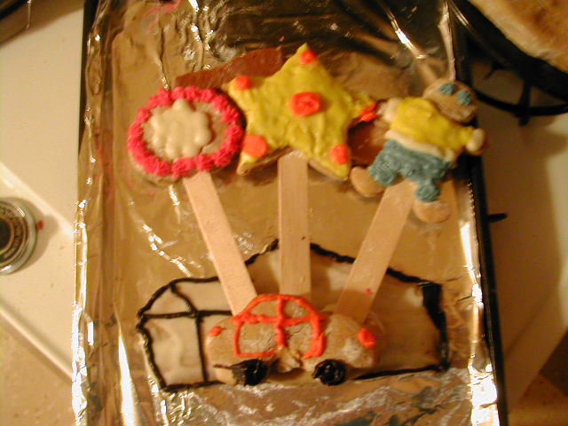
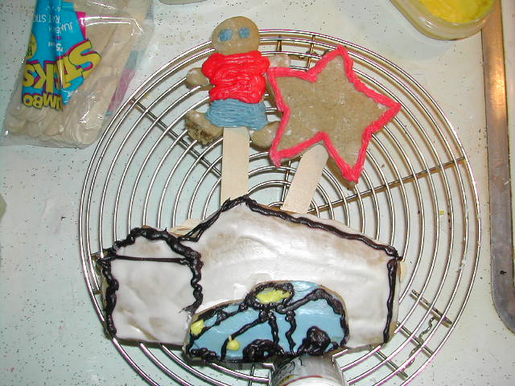 | 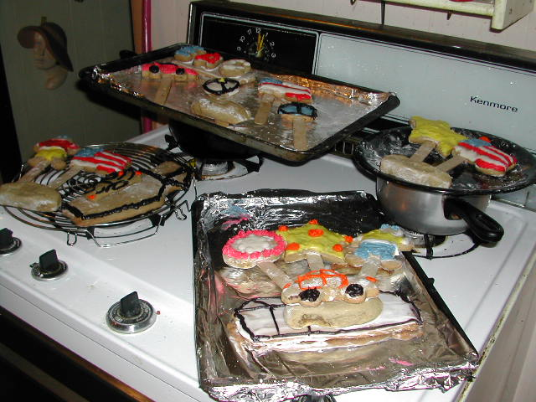
Drying and Ready to Package | 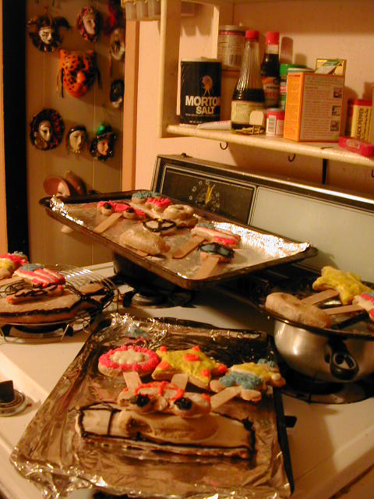
MATERIALS/TIME REQUIRED:
- Perishable
  - ingredients
- Non-Perishable
  - Equipment(cookie sheets, spatula, etc.), wrapping paper
  - Ink, paper, cards, tape, ribbon, bows
- RP TIME
  - Prep, Baking, Detailing, Packaging
- EAC TIME
  - Print time, paperwork

TV COMMERCIALS:
- A tiskit, a taskit, if you’ve had a wreck, we’ll give you a basket.
- As the cookie crumbles – soap opera style
- Cookie cars crashing
- Someone taking a bite out of car shaped cookie
- Cookies and milk??
- Humpty Dumpty

PRINT AD:
- Bite out of car shaped cookie
- Real picture of product

RADIO AD:
- As the cookie crumbles – radio theater style

PRINTWORK:
- Biz Cards
- Thank you

WEBSITE:
- Email coupon
- Website page about product

